Final Report on Prototype and Research Study

1. Representative prototype screenshots:

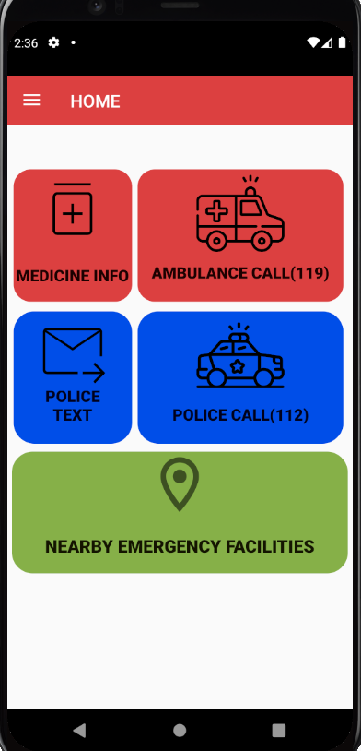 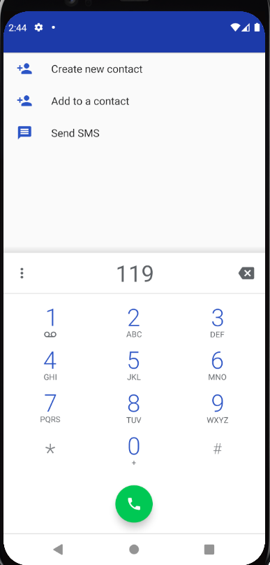

 

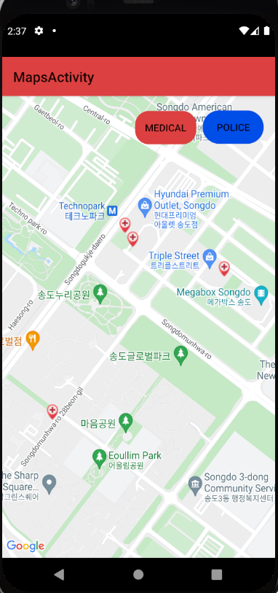 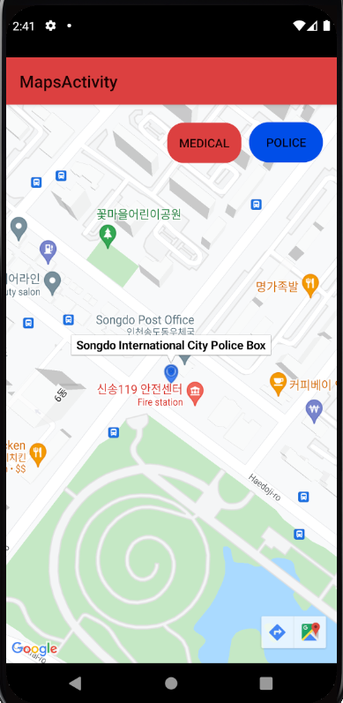

 

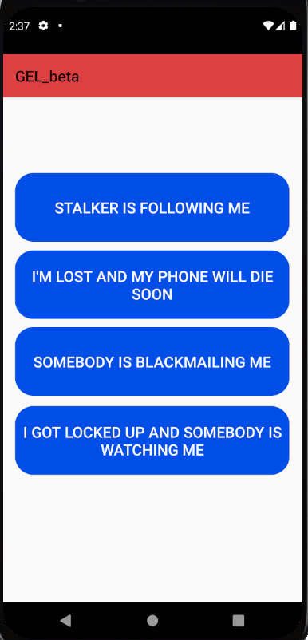 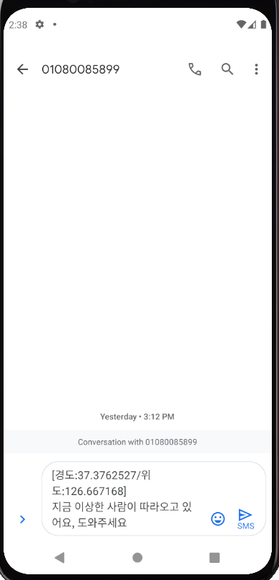

 

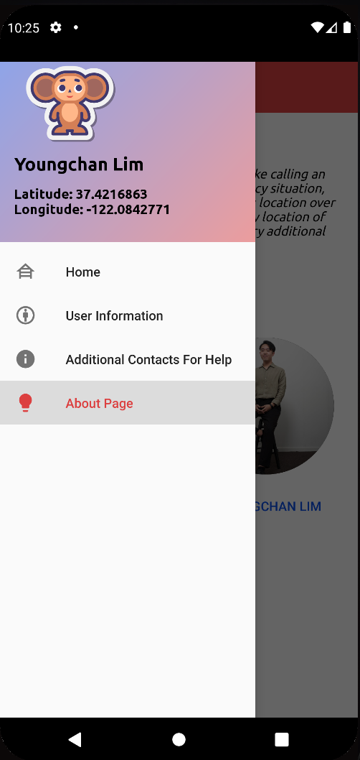 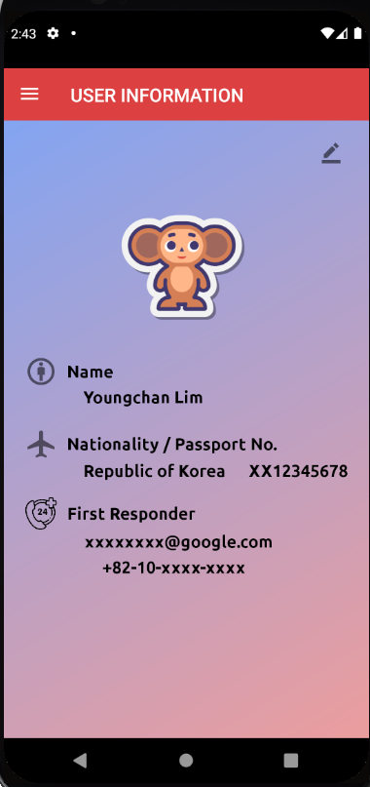

 

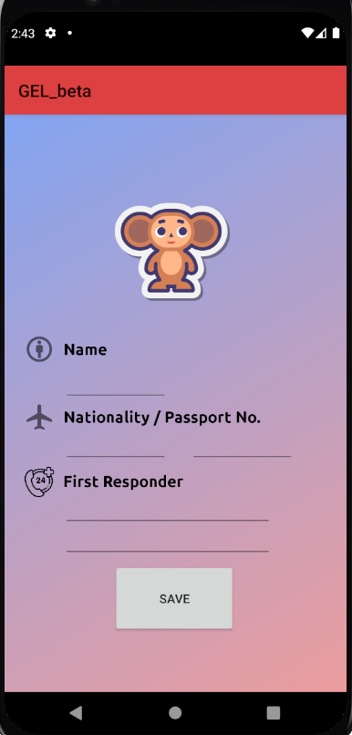 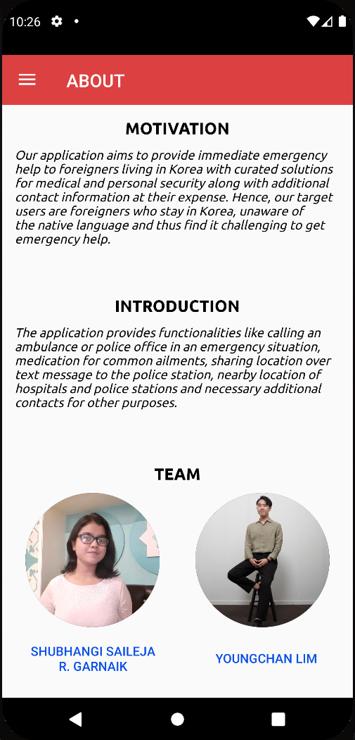

 

1. Changes since Iterative Prototype 1 (1-2 paragraphs):

Since prototype one many changes were incorporated based on the feedback from in class user testing activity and actual user testing. The major changes are as follows:

1. Decreased the navigation, as it is an emergency application. In such cases the user would prefer quick access to help.
2. A quick call to the emergency centers instead of hovering over the call button for three seconds to make a call.
3. For personal emergencies, instead of sending a report of the inconvenience, the application provides messaging functionality where the user's current location and a message is sent based on the type of emergency they face at that moment.
4. To access nearby police stations and hospitals, there is a single map button to provide both these functionalities instead of two separate buttons.
5. The additional contacts have been provided by clicking the hamburger icon on the top left of the screen, instead of a button on the main screen.
6. Research study Summary :
   1. what you decided to investigate in the study and why (2-4 sentences)
      1. Reveal the alternate applications like Emergency Ready App that people used during an emergency, and their experience with that product.
      2. Simplicity and accessibility of our application design. Access how users use Goto Emergency land app to overcome the issues faced in the existing application for emergency.
   2. The research methods you used: describe how you recruited your users, their demographics (if relevant), how your user study was structured, where you performed the tests, how long the session took, and how you analyzed the data.
      1. For the research study we have used the usability testing and interview followed by a short survey:
         1. For the usability test, we reached out to foreigners who have lived in Korea for more than a year. Their experience with emergency situations throughout the stay was very crucial for the study. We were able to meet two target users for the activity through a friend's contact.
         2. Both the participants are working professionals aged between 25 to 35 years and have stayed in Korea for a minimum of 4 years.
      2. The usability tests were conducted online over a zoom call. The sessions lasted for 20 - 40 minutes, where the participants were introduced to the aim of the study. During the test we observed the participants interact with the existing app - Emergency Ready App, where the participants were flustered with the usability of the app as it only provided nearby locations which were not displayed effectively. Eventually, they used our application and performed a few tasks considering they were in an emergency situation. Evaluating it for various scenarios they were satisfied with the functionalities provided, but had a few inputs for improvement.
      3. On Analyzing the data: Based on the data collected during this study, it was concluded that our application was more accessible and easy to use. The options for reaching out for help during an emergency on our app would actually encourage users to use it over the existing app which only provides information of nearby aid locations. Sharing the current location of a user with the police for getting faster help was appreciated as users would choose to text discreetly when they are being stalked instead of making a call.
   3. Summarized results: describe any key findings from the user study
      1. One user suggested updating the current location data on the go when trying to get police help during a personal emergency.
      2. Would be great if details for how to take the medication and the number of doses a day is added to the medicine information for common disorders.
      3. The police help could be clubbed for other emergency situations like an open fire, building collapse or any accident.
7. Prototype Quality Arguments :
8. Our application was built to provide effective emergency aid to foreigners living in Korea. Before we decided to develop this application, we looked up similar existing applications. One such application is the Emergency Ready App provided by the government of Korea, however we observed that the app was not easy to use and provided emergency help like nearby institutions for help for various problems which a user might not need that frequently.
9. We took into account the existing issues with the application and the reviews of dissatisfied users. After brainstorming enough we decided to provide emergency help for two main issues i.e, medical and personal safety emergency and any additional contact information for foreigners. During an emergency it is common for people to make a call for prompt assistance, thus we started with finalizing the call functionality. Using the call button the user can reach out for medical and personal security help with a single click. To avoid accidentally calling any emergency center, we allow the user to check and then proceed to make a call. This avoids any room for error and is not disappointing for the user to use the function.
10. The application contains a functionality to text police for help during an emergency situation. It is a function that specially abled and normal users can use for personal security, where users can send a text to the police based on a set of some common security issues faced by the local inhabitants. On clicking the police text button a message is drafted with the user's current location i.e, longitude and latitude values and additional information, which when sent to a police officer can provide quick help. For common health disorders, our application provides medication details with the name and image of the medicine to the user so that they can purchase it from nearby pharmacists when required without having to know how to pronounce it.
11. One of the main functionality of our application is providing nearby locations for help during an emergency via maps.



For this the application accesses the users current location and suggests close by located hospitals and police offices. Two buttons namely ‘Medical’ and ‘Police’ on the screen are provided to filter out emergency help locations based on the requirement at that point in time. Thus it improves the usability of the application by decreasing the number of navigation as considered during our initial prototypes and provides instant information with a single click.

1. The additional contacts are provided on the sidebar on clicking the hamburger icon on the top left of the main screen. This is because the additional contact information can be accessed when required and is not urgently required during an emergency. It contains contact information that foreigners might need during their stay like foreign tourist information,immigration contact, multicultural family support and lost and found.
2. A user can add or edit his/her details in the user information section which include the name, nationality, passport and responders information. Having this information updated users can get immediate help when required. Lastly, the user can navigate to the home screen directly by clicking the home button on the sidebar.
3. The GEL application provides functionality that can be used by the end user to get instant help, irrespective of the language barrier or any type of disability. This makes the application more inclusive and accessible. The application is developed to be very intuitive and user friendly. It is tested for all functional buttons and icons which avoids a possibility of frustration among the users. This was a major drawback of the existing solution, the Emergency Ready App.
4. Appendix:
5. List of Interview questions: (semi-structured interview)

What are you thinking of as you look at the application?

What do you think about the product?

When and where do you think someone would use this application?

How would you go about performing the tasks in this application:

* + 1. Task 1 (decided on the go)
    2. Task 2 (decided on the go)

Was anything different or did not perform as expected?

Was the interface easy to use and understand?

What motivated you to navigate that way to perform this task?

1. Notes from usability testing interview:
2. User 1

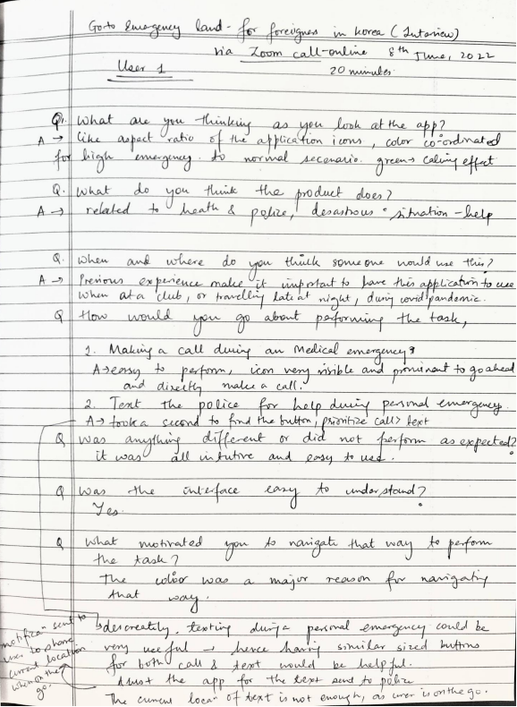

1. User 2

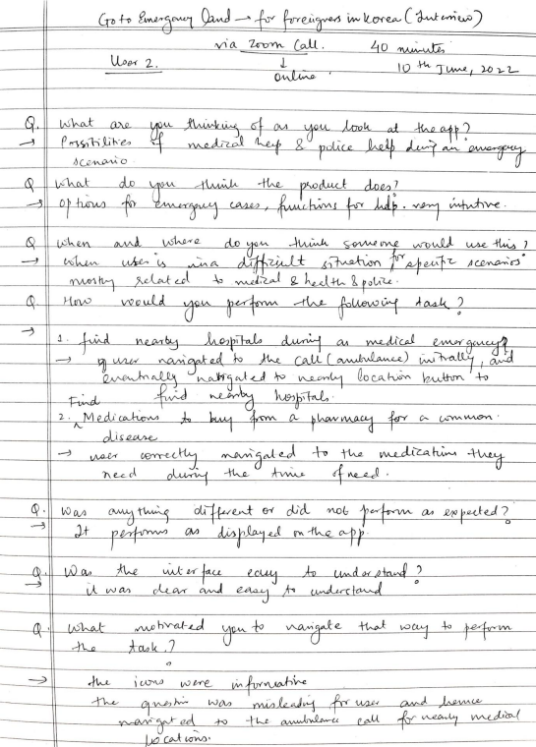

1. Scan of survey questions:

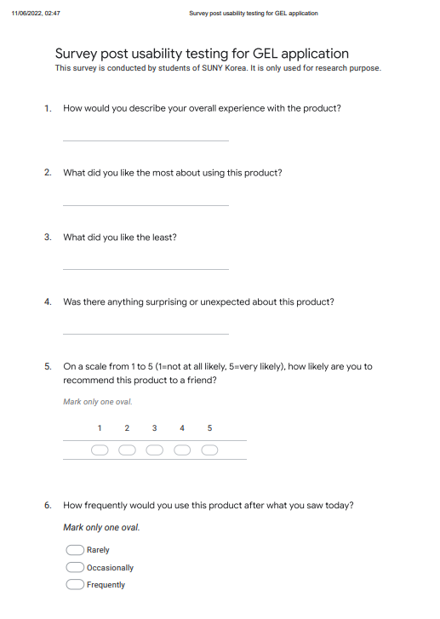

1. Scan of survey response after the usability test:
   1. First survey response: <Interview session 1, June 8th 2022, By Shubhangi and Youngchan Lim >

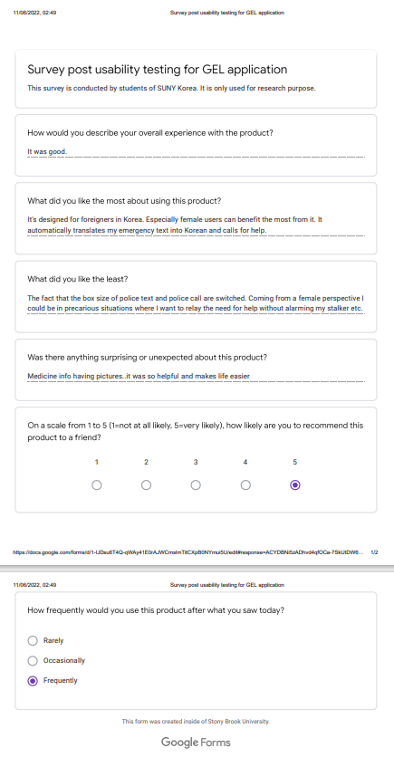

* 1. Second survey response: <Interview session 2, June 10th 2022, By Shubhangi and Youngchan Lim >

